SWT 22022-Practical for Internet Application Development
Department of Information and Communication Technology
Faculty of Technology
Lab sheet :01
Reg. Number: SEU/IS/20/ICT/084
Academic Year :2020/2021
Date: 2024.0.03
Practical No :01

Title:
- Introduction to PHP ( Hypertext Preprocessor ).

Aims:
- Refresh the knowledge on basic of PHP with HTML.
- Understand the concepts of PHP.

Tasks:
- Configure PC
- Basic Syntax of PHP
- PHP Comments
- PHP variable
- PHP Data Types
- PHP Constant
Activities
1. Configure PC to work with Server-Side Programming (PHP).
I. Install XAMP server
• https://www.apachefriends.org/download.html
• Download an installer according to your operating system → Doubleclick the installer →Next → Next (Select the components)→Next(Select the location) →Next (Select Language ) → Next → Finish
II. Install Visual Studio Code
• https://code.visualstudio.com/download
• Download an installer according to your operating system → Doubleclick the installer → Accept the agreement → Next → Choose the location → Next →Next → Select additional tasks → Next → Install → Finish

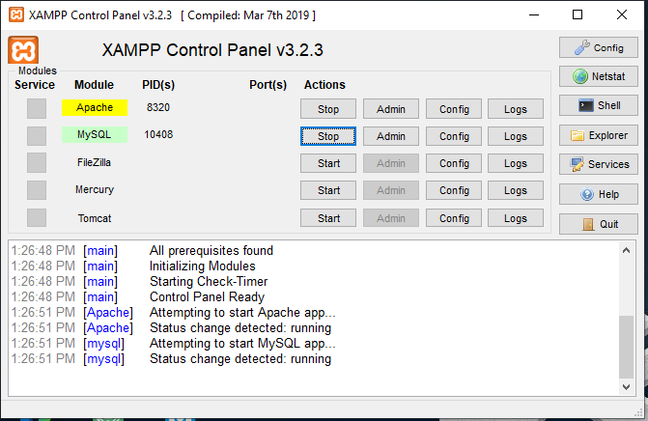

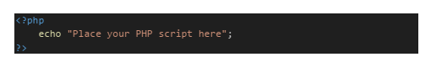
2. Basic Syntax of PHP

I. Create a new file and name it “name.php”.
II. Print your name only using echo function. III. Contain the script within html and run again.

name.php

<?php

echo "My Name is Kalhara";

?>

Output:

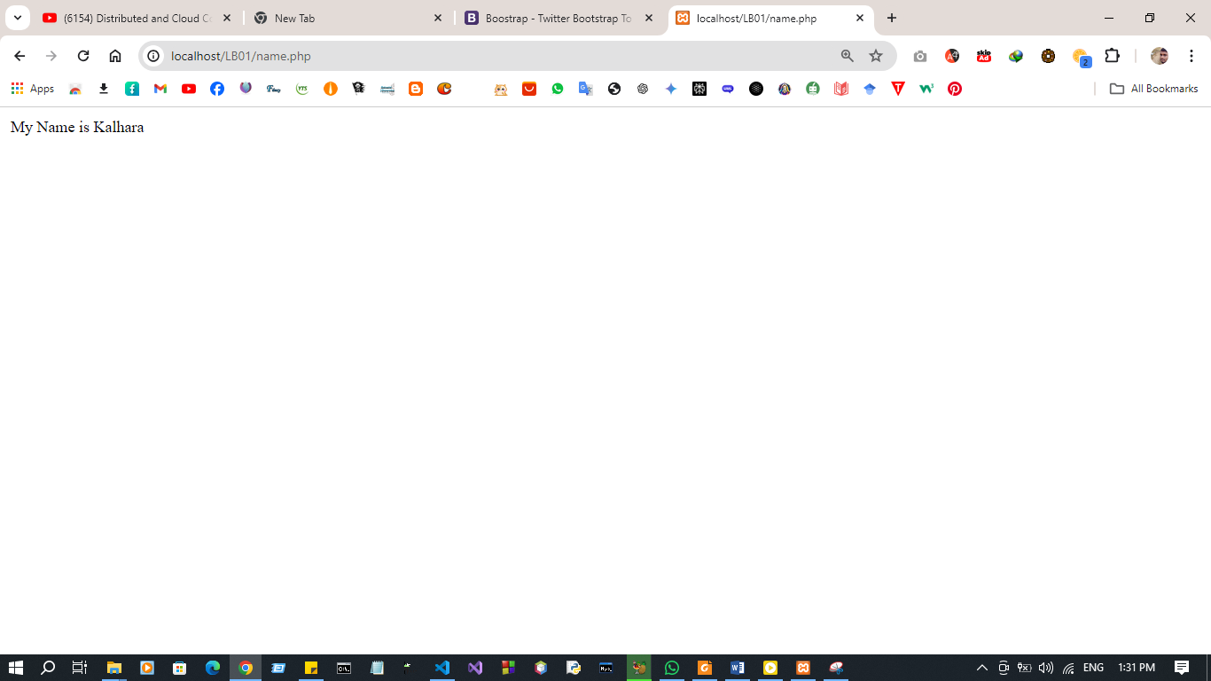
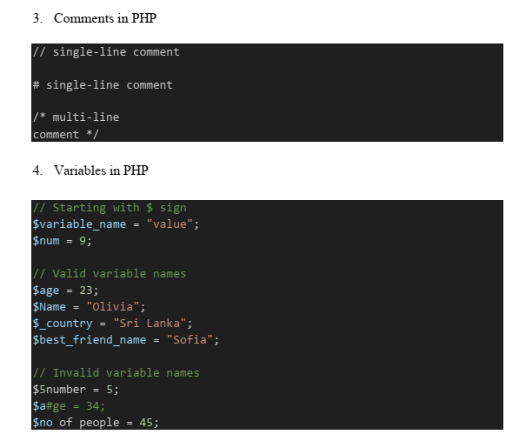

I. Create a new PHP file and name it “greeting.php”.
II. Define three variables to store your friend's name, age, and weight.
III. Display a greeting message to your friend. Ex:- "Hello, Olivia. Have a nice day!".
IV. Display your friend's age and weight on a new line.

greeting.php

<?php
$name="Olivia";
$age=25;
$weight=6.1;

echo "Hello ".$name.". Have a niceday!. <br>";
echo "oliva age is : ".$age."<br>";
echo "oliva weight is :".$weight."<br>";

?>

Output:

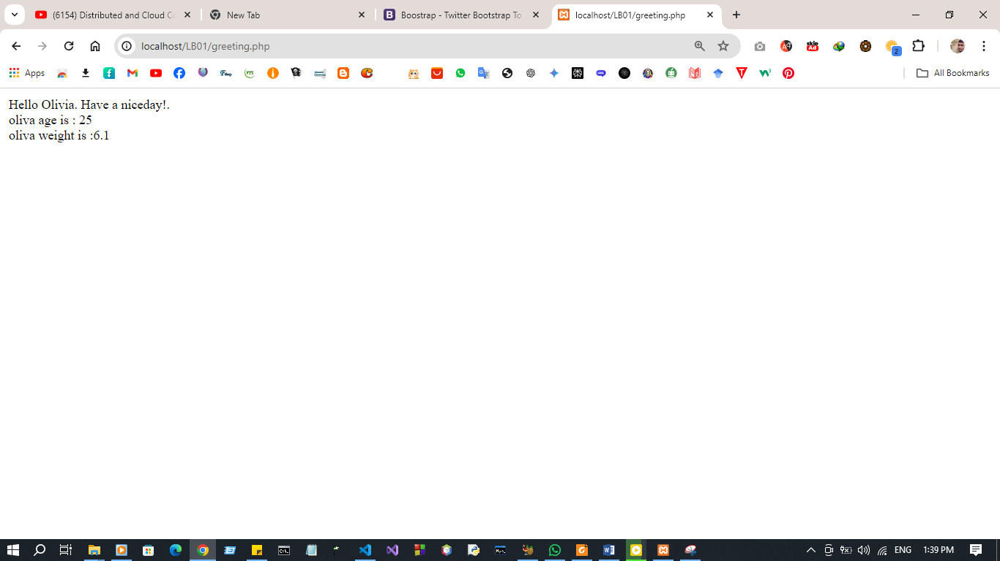

5. Data Types in PHP

// String
$name = "John Doe";
// Integer
$age = 30;
// Float (Double)
$temperature = 20.10;
// Boolean
$isActive = true;
$isValid = false;
// Array
$customers = [];
// NULL
$emptyValue = null;
// Object
//Resource

I. Create a new PHP file and name it “data_types.php”
II. Declare variables for customer name, product id, discount rate, is registered, shopping cart(empty array) , not found.
III. Display the data type of above variables using var_dump() function

data_types.php

<?php
$customer_name = "Pasan Kalhara";
$product_id = 001;
$discount_rate = 0.15;
$is_registered = true;
$shopping_cart = array();
$not_found = null;

var_dump($customer_name);
echo "<br>";
var_dump($product_id);
echo "<br>";
var_dump($discount_rate);
echo "<br>";
var_dump($is_registered);
echo "<br>";
var_dump($shopping_cart);
echo "<br>";
var_dump($not_found);

?>

Output:
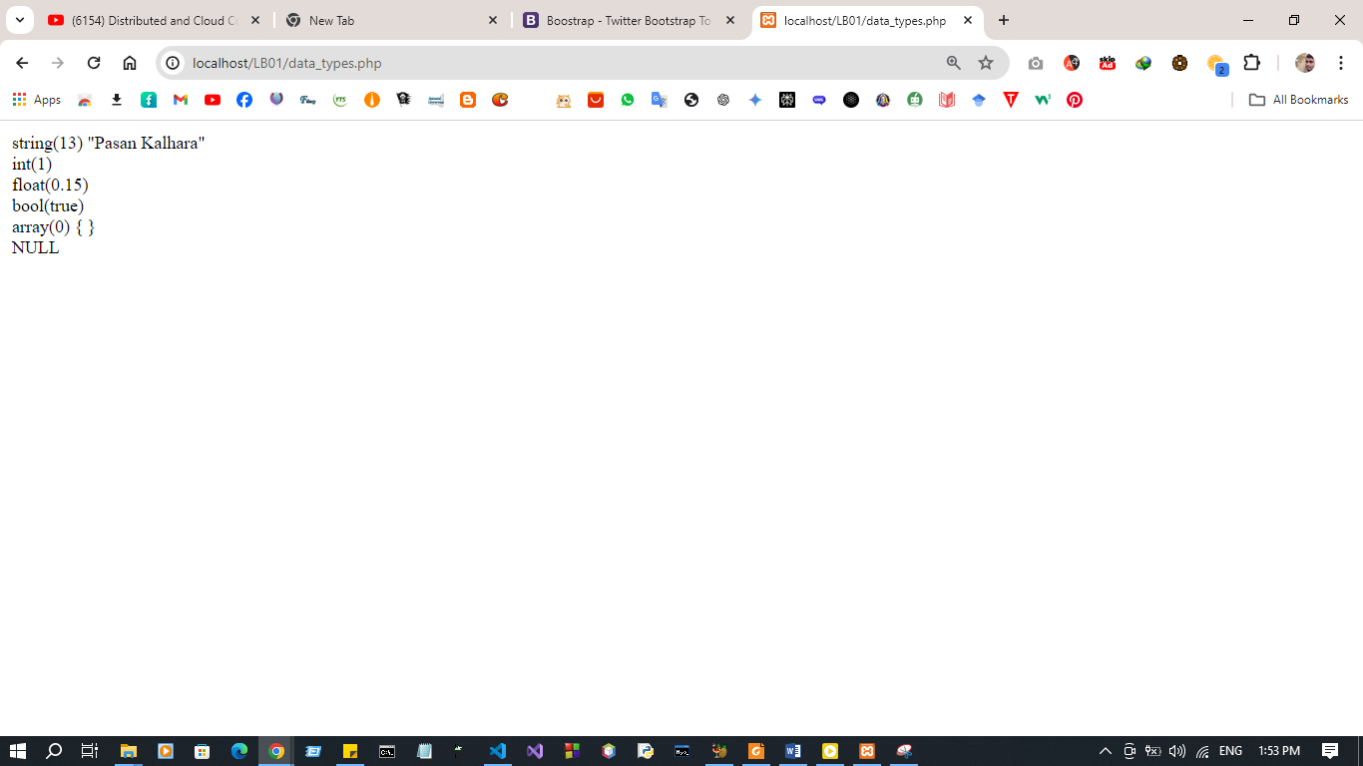

6. Constant in PHP

// define(name_of_the_constant, value_of_the_constant)
define("PI", 3.14159);
echo PI;
// const key word
const MAX_ATTEMPT = 3;
echo "<br>".MAX_ATTEMPT

I. Create a new PHP file and name it “constant.php”.
II. Create a constant variable to store shipping cost.
III. Try to change the shipping cost after assign the value.

constant.php

<?php

define("SHIPPING_COST", 5.99);
echo "Initial Shipping Cost: " . SHIPPING_COST . "<br>";
const Updated_SHIPPING_COST =9.9;
echo "Updated Shipping Cost: " . SHIPPING_COST ;
?>

Outpu:
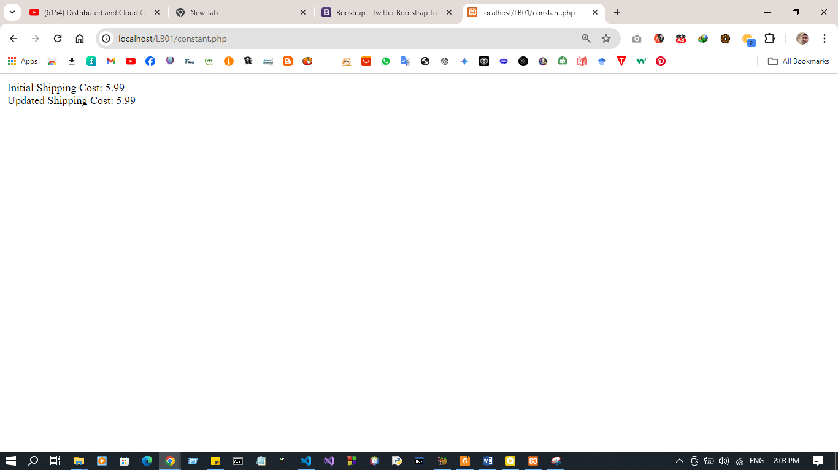
Discussion:
- In this session, the goal is to refresh the basics of PHP and its integration with HTML while deepening our understanding of key PHP concepts. We start by configuring the PC for PHP development, ensuring that the necessary software like a web server (e.g., XAMPP) is set up. The focus then shifts to PHP's basic syntax, which is essential for writing proper PHP code within an HTML structure. We also explore the use of comments in PHP, a crucial practice for making code more readable and maintainable. The session further covers PHP variables, which store data values, and data types (such as strings, integers, arrays, etc.), which define the nature of the data being used. Lastly, PHP constants are introduced, which are like variables but hold values that cannot change. Understanding these fundamentals is key to writing efficient and clear PHP code.

